**Dual-structure features for heavy ion and light particles at NICA collider**

Kolokolchikov S.1, Senichev Yu. 1, Aksentyev A. 1,2, Melnikov A. 1,3

1Institute for Nuclear Research of the Russian Academy of Sciences, Moscow, Russia

2National Research Nuclear University MEPhI, Moscow, Russia

3Landau Institute for Theoretical Physics, Chernogolovka, Russia

**Abstract**

The NICA collider will be used for both collider experiments with heavy ions and light polarized nuclei. The different charge-to-mass ratio is essential in magneto-optics design. To achieve high luminosity sufficient beam lifetime must be guaranteed. Transition energy crossing must also be solved.

**Introduction**

For successful collider experiments, it is essential to maintain a sufficient beam lifetime [1]. Additionally, it is crucial to solve transition energy issue in order to achieve the desired beam emittance required for high luminosity [2]. Both parameters impose significant constraints on the beam parameters.

The dual magneto-optical structure opens up the prospect of accelerating both heavy ions, such as gold, and light particles like protons and deuterons. The design of this structure requires a different approach due to the varying charge-to-mass ratios involved.

**Beam lifetime**

The lifetime of the beam luminosity in a collider experiment is achieved through the reduction of intra-beam scattering effects, coupled with the application of stochastic and electron beam cooling techniques. This approach assumes particular significance when dealing with high-intensity ion beams. The temporal evolution of emittance and momentum spread in the presence of cooling processes is governed by a set of equations

$$\begin{aligned}&\frac{dε}{dt}=\underset{\text{cooling }}{\underbrace{-\frac{1}{τ_{tr}}⋅ε}}+\underset{\text{heating }}{\underbrace{{\left(\frac{dε}{dt}\right)}_{IBS}}} \\ &\frac{dδ^{2}}{dt}=\underset{\text{cooling }}{\underbrace{-\frac{1}{τ_{\text{long }}}⋅δ^{2}}}+\underset{\text{heating }}{\underbrace{{\left(\frac{dδ^{2}}{dt}\right)}_{\text{IBS }}}} \\ &\end{aligned} (1)$$

where $ε$– transverse emittance, $τ_{tr}$– transverse cooling time, $δ=\frac{Δp}{p}$– momentum spread, $τ_{\text{long }}$– longitudinal cooling time.

For time-independent, stationary values, the time derivatives become zero, then

$$\begin{aligned}&ε_{st}={\left.τ_{tr}⋅{\left(\frac{dε}{dt}\right)}_{IBS}\right|}_{ε=ε_{st}} \\ &δ_{st}^{2}={\left.τ_{\text{long }}⋅{\left(\frac{dδ^{2}}{dt}\right)}_{IBS}\right|}_{δ^{2}=δ_{st}^{2}}\end{aligned} (2)$$

The benchmark for evaluating the effectiveness of a cooling technique can be determined by comparing the timescales of stochastic or electron cooling processes to the beam lifetime due to IBS over the entire energy spectrum.

**Stochastic cooling**

Let's consider stochastic cooling using the approximate theory developed by D.Mohl [3,4]. Based on his main findings, the cooling rate can be determined using the following expression:

$$\frac{1}{τ_{tr,l}}=\frac{W}{N}[\underset{\begin{aligned}\text{ coherent } \\ \text{ effect(cooling) }\end{aligned}}{\underbrace{2g\left(1-1/M_{pk}^{2}\right)}}-\underset{\begin{aligned}\text{ incoherent } \\ \text{ effect(heating) }\end{aligned}}{\underbrace{g^{2}\left(M_{kp}+U\right)}}] (3)$$

where $W=f_{max}-f_{min}$– system bandwidth, $N$– effective number of particles, recalculated based on the ratio of orbit length to the beam length, considering its distribution, $g$– fraction of observed sample error corrected per turn, $U=E({x_{n}}^{2})/E({{〈x〉}_{s}}^{2})$– the ratio of noise to signal, $M_{pk}$ *, $M_{kp}$* – mixing factors between the pickup – kicker and the pickup – kicker, respectively. Equation (3) in the absence of noise at $g=g_{0}=\frac{1-{M_{pk}}^{2}}{M_{kp}}$ reaches the maximum

$$\frac{1}{τ_{tr}}=\frac{W}{N}\frac{{\left(1-1/{M_{pk}}^{2}\right)}^{2}}{M_{kp}} (4)$$

$$\frac{1}{τ_{l}}=2\frac{W}{N}\frac{{\left(1-1/{M_{pk}}^{2}\right)}^{2}}{M_{kp}} (5)$$

The mixing coefficients are defined as

$$\begin{aligned}M_{pk}&=\frac{1}{2\left(f_{max}+f_{min}\right)η_{pk}T_{pk}\frac{Δp}{p}} (6) \\ M_{kp}&=\frac{1}{2\left(f_{max}-f_{min}\right)η_{kp}T_{kp}\frac{Δp}{p}} (7)\end{aligned}$$

where $η_{pk}T_{pk}\frac{Δp}{p}, η_{kp}T_{kp}\frac{Δp}{p}$– relative particle displacement times (mixing), $η_{pk}, η_{kp}$ – slip-factor, as a first approximation $η_{pk}=α_{pk}-1/{γ^{2}}, η_{kp}=α_{ kp}-1/{γ^{2}}$, $α_{pk}, α_{ kp}$– first-order of local momentum compaction factors, $T_{pk}, T_{kp}$– the absolute times between the pickup–kicker and kicker- pickup, respectively. The stochastic cooling times of eqs. (4-5) depend on the ratio of the effective particle density to the cooling system bandwidth and the properties of magneto-optics, local momentum compaction factors $α_{pk}, α_{ kp}$.

The maximum value of the frequency band is determined by the requirement that the "Schottky" beam bands do not overlap. In the simplest case, this can be expressed:

$$f_{max}<\frac{1}{η_{pk}T_{pk}\frac{Δp}{p}}, (8)$$

thus, a mixing factor $M_{pk}>1$. Otherwise, the cooling efficiency becomes zero. Thus, for a given number of particles, it is desirable to achieve the highest possible frequency band. From an electron perspective, modern technologies allow for the implementation of a 10 GHz frequency band [5], however, its use is not always feasible due to the large magnitude of the slip-factor $η_{pk}$ and momentum spread $\frac{Δp}{p}$.

Equation (3) has been derived for coasting beam. Particle density for a single harmonic RF resonator is described by a Gaussian distribution

$$ρ(s)=\frac{N_{bunch}}{σ_{bunch}\sqrt{2π}}∙e^{-\frac{s^{2}}{2σ_{bunch}^{2}}} (9)$$

where $s$– the distance from the beam center, $σ_{bunch}$– the dispersion of the particle distribution, and $N_{bunch}$– the number of particles. Assuming that cooling is at its minimum at the center ($s=0$), the effective particle number at orbit length $C_{orb}$ can be calculated as follows:

$$N=\int_{0}^{C_{orb}}{ρ_{max}ds}=\frac{N_{bunch}}{\sqrt{2π}σ_{bunch}}∙C_{orb} (10)$$

For a beam generated by a multiharmonic barrier-type RF system, so-called "Barrier Bucket", the particles distribution in the beam can be considered approximately uniform along its entire length. The effective particles number is determined by a simple ratio of the beam length to the total orbit length:

$$N=\frac{N_{bunch}}{{4σ}_{bunch}}∙C_{orb} (11)$$

To summarize, the effective value of particles depends on their distribution and is determined by their form-factor $F_{bunch}=\sqrt{2π}÷4$

$$N=N_{bunch}∙\frac{C_{orb}}{F_{bunch}∙σ_{bunch}} (12)$$

For NICA considered maximal form-factor $F_{bunch}=4$ with $C_{orb}=503.04$ m, $σ_{bunch}=0.6$ m, $N_{bunch}=2.2∙{10}^{9}$. Considering the accumulated FNAL [6] experience, quite realistic values for the frequency band are $f_{max}=8$ GHz and $f_{min}=2$ GHz. For NICA $f_{max}=4$ GHz and $f_{min}=2$ GHz. With these parameters, the maximum achievable cooling rate is $1/{τ_{tr}}=1/{230} s^{-1}$.

Based on equations 6-7, it is evident that asymptotic growth may occur in two scenarios:

1. the slip-factor approaches the value $η→\frac{1}{2\left(f_{max}+f_{min}\right)T_{pk}\frac{Δp}{p}}$, the beam Schottky spectrum becomes continuous and $M_{pk}→1$;
2. slip-factor approaches zero, mixing between the kicker to the pickup does not occur and $M_{kp}→∞$.

The efficiency of stochastic cooling depends on the properties of magneto-optics. In classical “*regular”* structures, transition energy is acquired through the horizontal frequency $γ_{tr}≈ν_{x}$ and slip-factor $η=1/γ_{tr}^{2}-1/γ^{2}$ can achieve zero. To avoid asymptotic growth, it is necessary to vary the slip-factor which means $γ_{tr}$. This is possible in “*resonant*” structure, where transition energy can be increased or even reach complex value [7]. In more exotic case, can be used “*combined*” structure then $η_{pk}$ (pickup-kicker) with real transition energy at one arc

$$η_{pk}=1/γ_{tr}^{2}-1/γ^{2} (13)$$

compensated by $η_{kp}$ (kicker-pickup) with complex transition energy at another

$$η_{kp}=-1/γ_{tr}^{2}-1/γ^{2} (14)$$

for the whole ring. Such structure achieves the required ratio of mixing factors for a maximum cooling rate close to ideal [10]. Let us delve deeper declared structures in more detail.

The behaviour of the $β$-functions and $D$ the dispersion across the entire “*regular*” ring illustrates at Fig. 1. The straight sections, which remain constant in all structures, are essential for analyzing of the resonant characteristics of the entire structure. Their arrangement does not affect the intra-beam scattering and transition energy. To suppress dispersion in the “*regular*” structure, ‘missing magnets’ technic implemented on both sides of the arc.

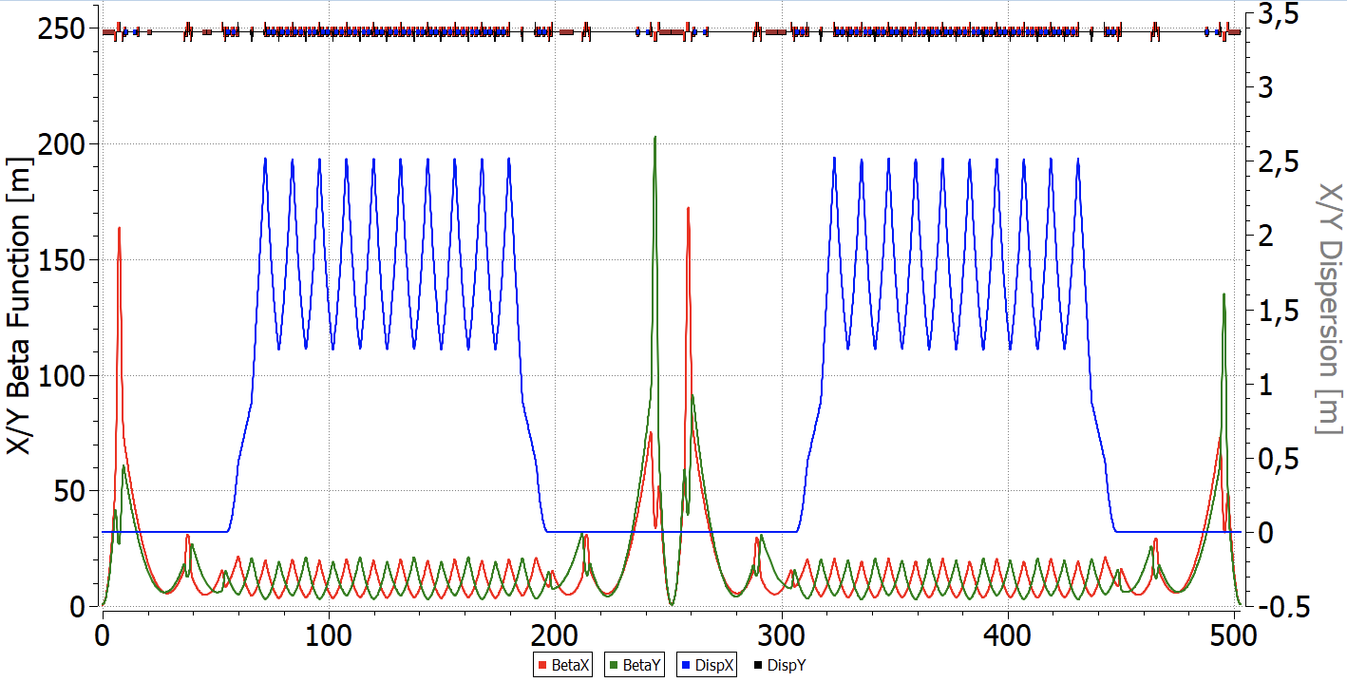

Fig. 1 “Regular” FODO structure.

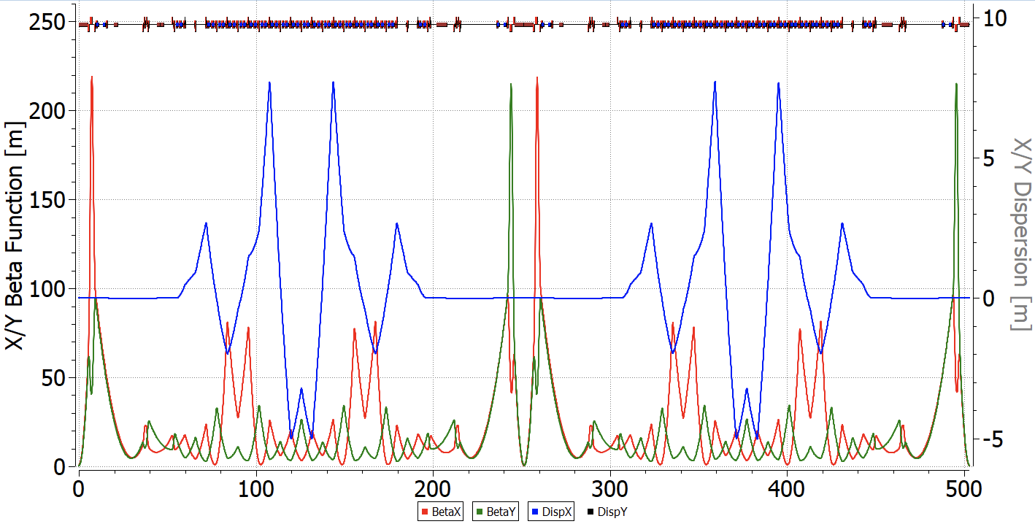The “*resonant*” structure is based on the principle of resonant modulation of the dispersion function [8] and can be obtained from a "*regular*" one by dividing focusing quadrupoles into 2 families with different gradients. In this way, the transition energy can be adjusted to increase it above the experiment energy, avoiding problems with transition energy crossing. To suppress dispersion can be used either two edge focusing quadrupoles on both sides of the arc or only two families of focusing quadrupoles on the arc [9], when an integer number of betatron oscillations is reached (Fig. 2).

Fig. 2 "Resonant" magneto-optic structure with increased transition energy.

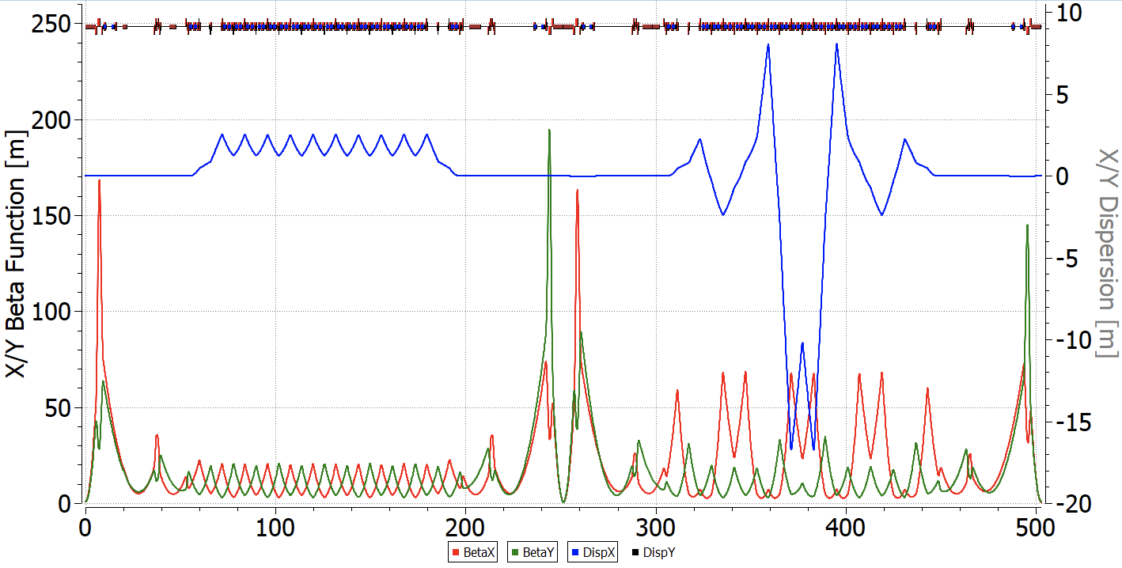In the case of a “*combined*” structure, one arc operates in a regular mode, while the other employs resonant modulation (Fig. 3). Such choice is based on the principle of compensation, as described by eqs. 13 and 14, which requires a greater modulation depth of the quadrupoles than in purely "*resonant*" structure with increased transition energy.

Fig. 3 "Combined" magneto-optic structure with real and complex transition energies in arcs.

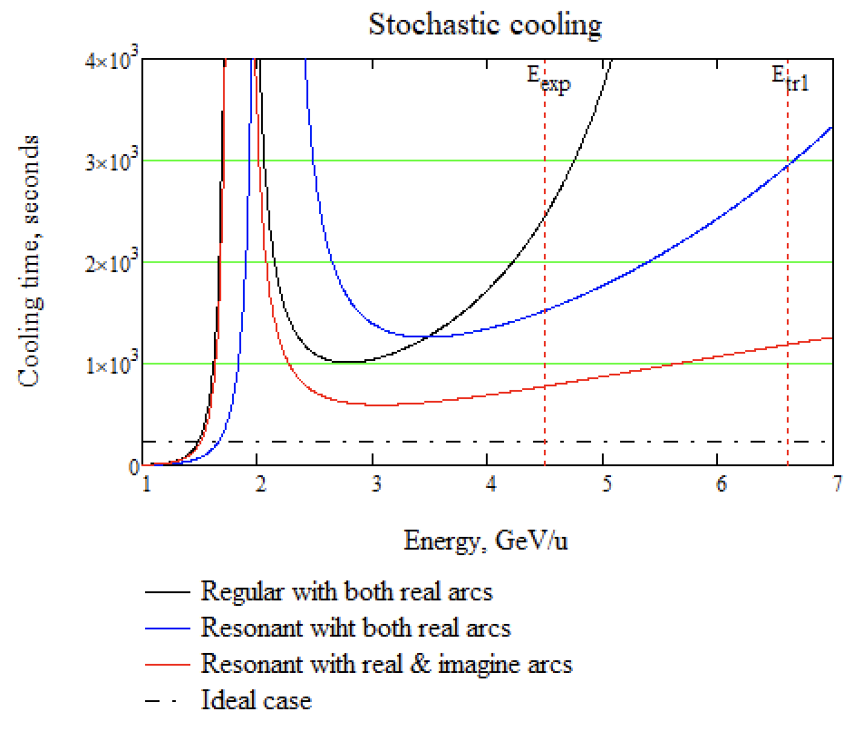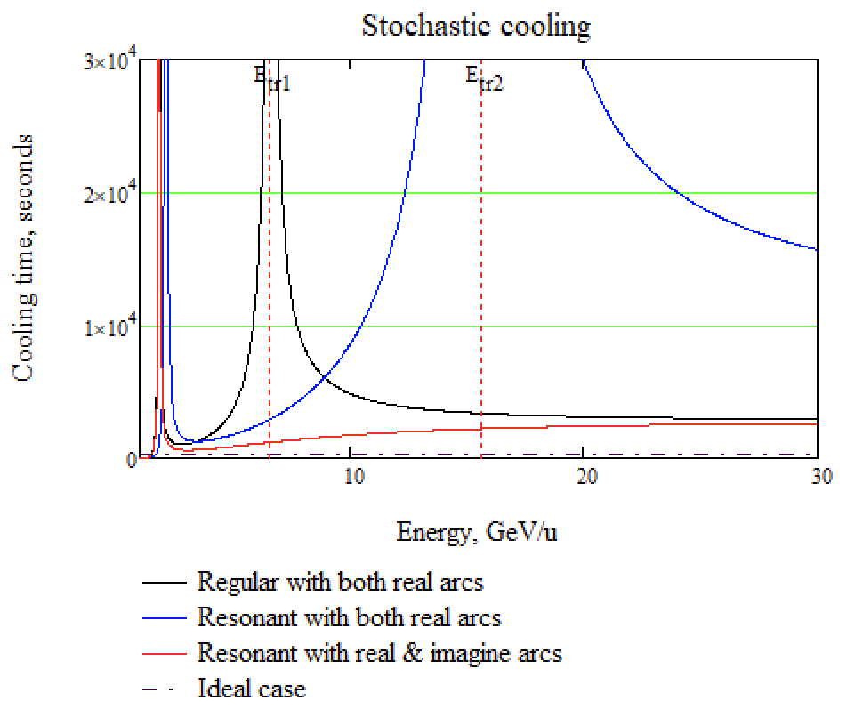 As illustrated in Figure 4, "*resonant*" optics with increased transition energy, the second asymptotic is at higher energy compared to the “*regular”* structure. In “*combined*” magneto-optics, the cooling efficiency is closer to the ideal value in a large energy range from 2.5 to 4.5 GeV, while in “*regular”* optics the cooling rate is almost two times lower at the most optimal point ~3 GeV. This behaviour is explained by absence of the second point of asymptotic growth.

Fig. 4 The dependence of stochastic cooling time on the energy.

**Intra-beam scattering**

Intra-beam scattering represents a fundamental limitation on the beam lifetime in the collider. Consequently, the selection of an appropriate cooling technique hinges on comparing its characteristic time scales with the rate at which the beam is heated due to intra-beam scattering. This is derived from the fundamental principles governing this process

$$\frac{1}{τ_{IBS}}=\frac{\sqrt{π}}{4}\frac{cZ^{2}r_{p}^{2}L_{C}}{A}⋅\frac{N}{C_{\text{orb} }}⋅\frac{\left\langle β_{x}\right\rangle }{β^{3}γ^{3}ε_{x}^{5/2}\left\langle \sqrt{β_{x}}\right\rangle }\left(\left\langle \frac{D_{x}^{2}+{\dot{D}}_{x}^{2}}{β_{x}^{2}}\right\rangle -\frac{1}{γ^{2}}\right). (13)$$

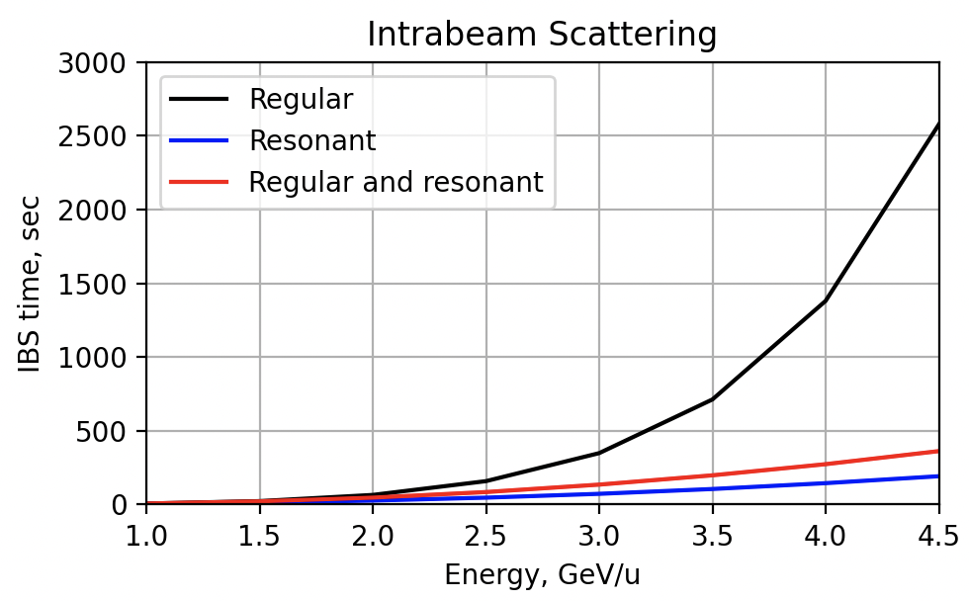Unlike stochastic cooling, the IBS rate increases as decreasing energy $1/γ^{3}$. In addition, the expression in parentheses is proportional to the slip-factor $η$. Therefore, it should be expected that in optics with a value $η$ close to zero, the heating rate should decrease. Figure 4 shows the dependences of the heating time constant in the three above-mentioned structures calculated using MADX programs [11] for the parameters of the heavy ion beam ${}_{79}^{197}{Au}$ of the NICA collider with maximum luminosity ${10}^{27} {sm}^{-2}s^{-1}$.

From the comparison of the IBS lifetime with the cooling time (see Fig. 4) it can be concluded that in a regular structure, stochastic cooling is able to balance intra-beam scattering in the energy range $W≥4.5$ GeV. In order to apply stochastic cooling over the entire energy range, it is obvious that we must sacrifice the luminosity of the beam at low energies by increasing the emittance. In resonant structures, the IBS time is notably reduced. This is explained by the fact that the structure has a greater ratio $\left\langle \frac{D_{x}^{2}+{\dot{D}}_{x}^{2}}{β_{x}^{2}}\right\rangle$ between the dispersion and the beam $β$-function than in the case of a regular. Thus, for the case of heavy ions, the configuration should be regular and minimally modulated. Electron cooling is used in the regular structure to cool the beam lower 4.5 GeV [12].

Fig. 5 The dependence of the beam lifetime due to intra-beam scattering in “regular”, "resonant" and “combined” structures on the beam energy for heavy ion beam.

**Transition Energy**

In the context of light nuclei, such as protons and deuterons, the IBS time experiences a significant increase as the charge decreases. Consequently, the issue of intra-beam scattering becomes critical for heavy-ion beam.

Owing to the charge-to-mass ratio, the peak energy of the proton beam amounts to approximately 13 GeV. Meanwhile, the transition energy of the “*regular*” structure, which acts as a characteristic of the accelerator magneto-optical structure, stands at 5.7 GeV. Thus, transition energy needs to be overcome. The classical method involves a transition energy jump [13], but in this case, there are significant restrictions on the beam parameters [14]. Previously, has been demonstrated that dispersion modulation can increases transition energy or even reaches a complex value in a “resonant” magneto-optic structure [15].

|  |  |  |  |
| --- | --- | --- | --- |
| Structure | Regular | Resonant | Combined |
| Particles | $${}_{79}^{197}{Au}$$ | $$p,d$$ | $$p,d$$ |
| Experiment energy, GeV/u | $$4.5$$ | 12.6 | 12.6 |
| Transition energy, GeV | $$7$$ | $$15$$ | $$i50$$ |
| Modulation depth | - | 25% | 45% |

**Conclusion**

The dual magneto-optical structure is proposed for accelerating both heavy ion and light particle beams, exemplified by the NICA facility. Shown that the stochastic cooling time in “*resonant*” and “*combined*” structures is significantly shorter than in “*regular*” ones. However, due to modulation of $β$-function and $D$ dispersion, the time of intra-beam scattering decreases. For this reason, a “*regular*” magneto-optic structure with minimally modulated dispersion and $β$-function is optimal in the heavy-ion mode. In the case of protons, the problem of overcoming the transition energy is important, for this a “*resonant*” or “*combined*” magneto-optical structure can be used. It does not require a significant adjustment, only the allocation of a separate focusing quadrupole family.

**References**

1. Grigory Trubnikov, Anatoly Sidorin, Nikolay Shurkhno, NICA cooling program, CYBERNETICS AND PHYSICS, Vol. 3, No. 3. 2014, 137-146
2. Syresin, E.M., Butenko, A.V., Zenkevich, P.R. et al. Formation of Polarized Proton Beams in the NICA Collider-Accelerator Complex. Phys. Part. Nuclei 52, 997–1017 (2021). https://doi.org/10.1134/S1063779621050051
3. D. Möhl, G. Petrucci, L. Thorndahl and S. van der Meer, Phys. Rep. 58 (1980) 75
4. D. Möhl, Nuclear Instruments and Methods in Physics Research A 391 (1997), 164-171
5. F.Caspers, D. Möhl , Stochastic Cooling in Hadron Colliders, Proc. of XVII International Conference High Energy Accelerators, 1998, Dubna
6. M. Church, Stochastic cooling in Fermilab, Nuclear Instruments and Methods in Physics Research A 391 (1997) 172-175.
7. Senichev, Y.V., Chechenin, A.N. Theory of “Resonant” lattices for synchrotrons with negative momentum compaction factor. J. Exp. Theor. Phys. 105, 988–997 (2007). <https://doi.org/10.1134/S1063776107110118>
8. Senichev, Y.V., Chechenin, A.N. Construction of “resonant” magneto-optical lattices with controlled momentum compaction factor. J. Exp. Theor. Phys. 105, 1141–1156 (2007). <https://doi.org/10.1134/S1063776107120060>
9. Kolokolchikov, S.D., Senichev, Y.V. Magneto-Optical Structure of the NICA Collider with High Transition Energy. Phys. Atom. Nuclei 84, 1734–1742 (2021). https://doi.org/10.1134/S1063778821100185
10. Yu. Senichev, The advanced HESR lattice for improved stochastic cooling, American Institute of Physics, COOL-07 workshop, [Bad Kreuznach](http://www.bad-kreuznach-tourist.de/en/), Germany, 2007, <http://bel.gsi.de/cool07/TALKS/TUA2C07_TALK.PDF>
11. Antoniou, F., Zimmermann, F., Revision of Intrabeam Scattering with Non-Ultrarelativistic Corrections and Vertical Dispersion for MAD-X, CERN-ATS-2012-066.
12. С.А. Костромин и др., Применение методов охлаждения пучков в проекте NICA, Письма в ЭЧАЯ, 2012, Т.9. №4-5(174-175), C. 537-562.
13. Kolokolchikov, S., Senichev, Y., Aksentev, A. et al. Longitudinal Dynamic in NICA Barrier Bucket RF System at Transition Energy Including Impedances in BLonD. Phys. Part. Nuclei Lett. 21, 419–424 (2024). <https://doi.org/10.1134/S1547477124700389>
14. Kolokolchikov, S., Senichev, Y., Aksentev, A., Melnikov A., Transition energy crossing in NICA collider of polarized proton beam in harmonic and barrier RF, Phys. Atom. Nuclei Nuclei*, to be published.*
15. Kolokolchikov, S.D., Senichev, Y.V. Magneto-Optical Structure of the NICA Collider with High Transition Energy. Phys. Atom. Nuclei 84, 1734–1742 (2021). https://doi.org/10.1134/S1063778821100185